Bootloading an AudioLux One

1. Download and instal Arduino Software IDE
   1. <https://www.arduino.cc/en/Main/Software>  
      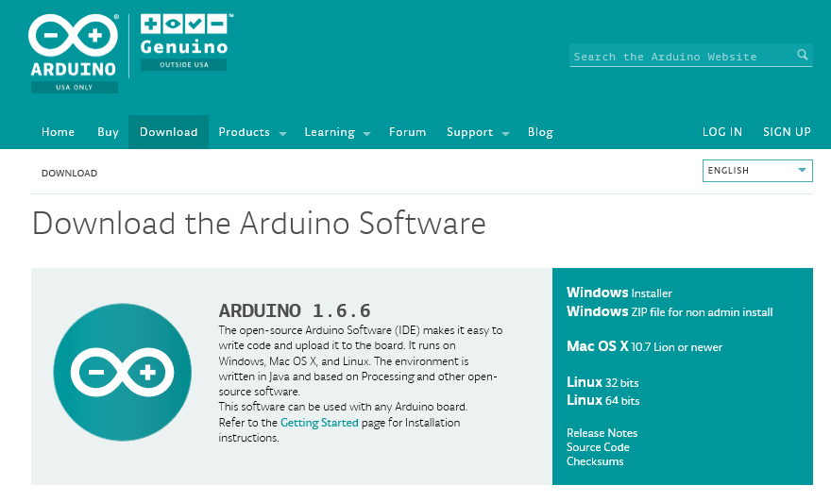
2. Find a Spare Arduino UNO r3
3. Open Arduino on the Computer
4. Click File🡪Examples🡪11.ArduinoISP🡪ArduinoISP
5. Connect your Arduino UNO r3 to the computer via USB cable and Select correct COM port that corresponds to your Arduino Uno r3
6. Click Upload
7. Preparing Your Newly soldered Audiolux One V0.9 Board
   1. Inspect all components make sure there are no shorted legs
   2. Turn off all dip switches (very important!)
8. Use Custom ICSP Cable to plug the Audiolux One V0.9 Board into the Arduino UNO r3
   1. Side with the Wire sticking out goes into the Arduino UNO r3 with the wire plugged into pin 10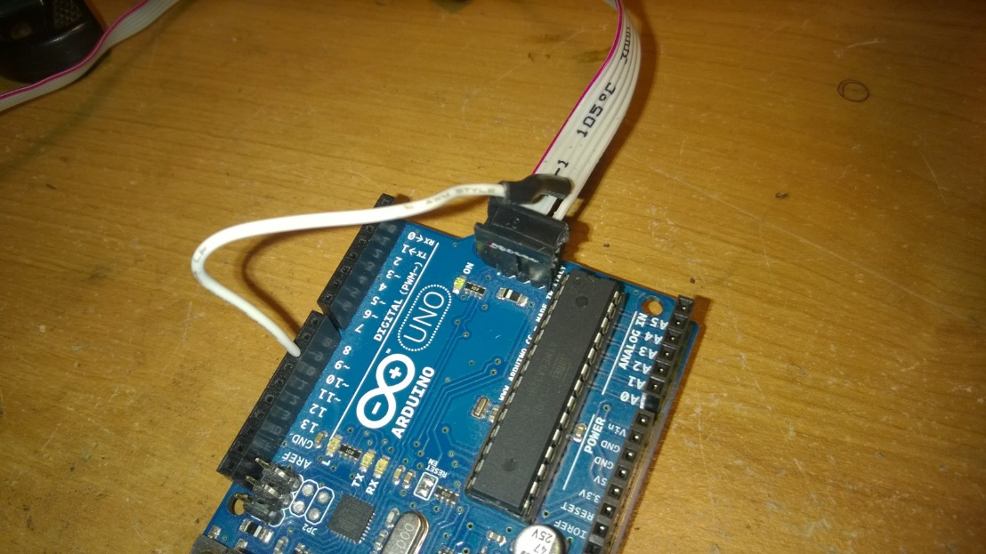
   2. The other Side goes into the Audiolux One V0.9 Board
      1. There is a black line on the cable that resembles pin number 1, to know the orientation plug the cable in a way that the black line is on the side of the square soldering pad on the Audiolux One V0.9 Board. 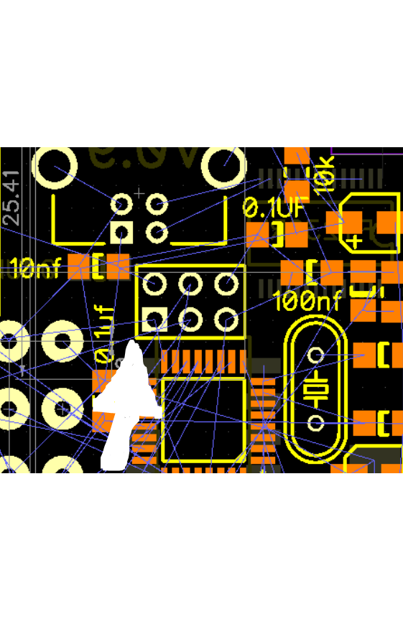
9. In the Arduino Program click Tools🡪Burn Bootloader
10. If the Bootloading completes with no errors then you are good to go now you can uplaod sketches via USB on the Audiolux One V0.9 Board
11. If you get an error check this:
    1. All the Dipswitches on the Audiolux One V0.9 Board are off
    2. Bootloading Cable is connected correctly
    3. No shorts on board chips
    4. Try pulling the cable out halvway not pushing it in all the way
    5. Bad ICSP Cable
    6. The red light on the Board should be on when cable is connected if it is not on the led is probably soldered the wrong way, or the ICSP Cable is bad